WEEK 1 (ML & Types)
Machine Learning (ML)
Machine Learning (ML) is a subfield of Artificial Intelligence (AI) that focuses on building algorithms and models that enable computers to learn from data and improve with experience without explicit programming for every task. In simple words, Machine Learning teaches systems to learn patterns and make decisions like humans by analyzing and learning from data.

Types of Machine Learning
- Supervised Machine Learning
- Unsupervised Machine Learning
- Reinforcement Learning

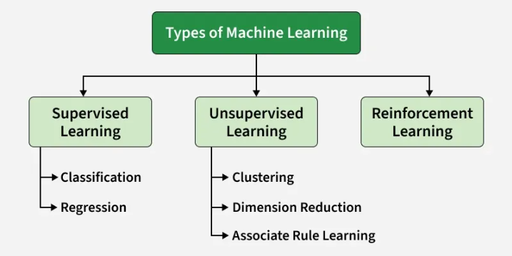

- Supervised Machine Learning

Supervised Machine Learning is when a model is trained on a "Labeled Dataset". Labeled datasets have both input and output parameters. In Supervised Learning,

algorithms learn to map points between inputs and correct outputs. It has both training and validation datasets labelled.

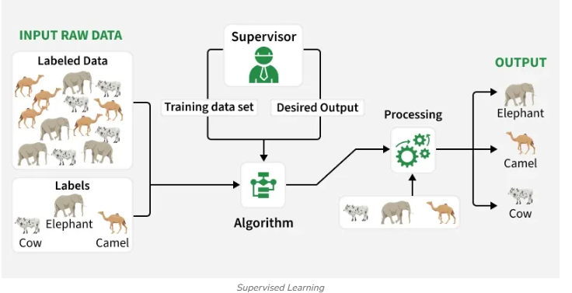
Example: If you train a model using labeled images of cats and dogs, it learns the features of each. When shown a new image, it predicts whether it’s a cat or a dog.

1. Classification
Classification predicts categorical outputs, meaning it assigns data into predefined classes like spam/non-spam emails or disease risk categories. These algorithms learn to map input features to discrete labels. Here are some classification algorithms:
Algorithm | Short Definition | Simple Example
Logistic Regression | Used for Binary classification. It predicts the probability of an outcome, usually Yes/No or 0/1. | Predict whether a student will pass or fail based on study hours.
Decision Tree | Used for both classification and regression tasks. Makes decisions by asking a series of questions, like a flowchart. | Study hours > 5? → Yes → Pass; No → Fail.
Random Forest | Combines many Decision Trees and uses their combined predictions to get a better result. | 100 trees predict whether an email is spam; if most say Spam, the final answer is Spam.
K-Nearest Neighbors (KNN) | Predicts a new data point based on the closest existing data points. | If most of the 5 students closest to a new student are Pass, predict Pass.
Naive Bayes | Uses probability to classify data. It assumes features are independent of each other. | For email classification, words like "win", "prize", "free" make it more likely to be Spam.
Support Vector Machine (SVM) | Finds the best boundary (line/plane) that separates different classes. | Separates cats and dogs based on features such as weight and height.

2. Regression
Regression predicts continuous values, such as house prices or product sales. It learns the relationship between input features and a numerical target variable. Here are some regression algorithms:
Algorithm | Short Definition | Simple Example
Linear Regression | Finds a straight-line relationship between input and a numeric output. | House size → House price
Polynomial Regression | Finds a curved relationship between input and a numeric output. | Experience → Salary
Ridge Regression | Regression with a penalty that helps reduce overfitting. | Predict house price using many features.
Lasso Regression | Regression with a penalty that can make unimportant feature coefficients zero, helping with feature selection. | From 20 features, identify the important ones for predicting price.
Decision Tree Regression | Uses questions/splits to predict a numeric value. | Size + rooms → House price
Random Forest Regression | Uses many Decision Trees and averages their predictions. | 100 trees predict house price → average = final price

Where to Use Supervised Learning
- When you have labeled data and want to predict outcomes.
- Ideal for classification (like spam detection) or regression tasks (like price forecasting).
- Best used in domains where historical data with outcomes is already available.

Applications
Supervised learning is used in a wide variety of applications, including:
- Image, speech and text processing: For tasks like image classification, speech recognition and sentiment analysis.
- Predictive analytics: To forecast sales, customer churn, stock prices and weather conditions.
- Recommendation and personalization: Powering systems that suggest products, movies or content.
- Healthcare and finance: Used for medical diagnosis, fraud detection and credit scoring.
- Automation and control: In autonomous vehicles, manufacturing quality checks, and gaming AI.
- Unsupervised Machine Learning
Unsupervised learning works with unlabeled data, meaning there are no predefined outputs. The algorithm finds hidden patterns, groups, or relationships within the data on its own. It’s mainly used for clustering, dimensionality reduction, and data visualization.
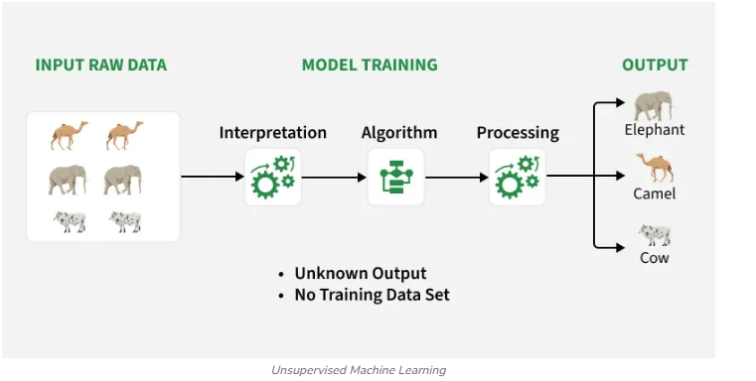

Example: If you have customer data without labels, the algorithm can group similar customers based on purchase behavior useful for segmentation and marketing.
Two main categories of unsupervised learning are mentioned below:
1. Clustering
Clustering is the process of grouping data points into clusters based on their similarity. This technique is useful for identifying patterns and relationships in data without the need for labeled examples. Common techniques include:
Algorithm | Short Definition | Simple Example
K-Means | Groups data into K clusters based on similarity. | Group customers into 3 groups based on spending.
DBSCAN | Groups data based on density and can identify outliers/noise. | Find crowded areas of customers and detect unusual customers.
Mean-Shift | Finds dense regions (clusters) by moving points toward the area with the highest concentration of data. | Group customers based on areas where many similar customers are located.

2. Dimensionality Reduction Techniques
Dimensionality Reduction helps reduce the number of features while preserving important information. Common techniques include:
Algorithm | Short Definition | Simple Example
PCA (Principal Component Analysis) | Reduces the number of features while keeping the most important information in the data. | Converts 10 features into 2 main components for visualization.
ICA (Independent Component Analysis) | Separates data into independent underlying components/signals. | Separates different people's voices from a mixed audio recording.

Where to Use Unsupervised Learning
- When data is unlabeled or unstructured.
- Useful for exploratory analysis, clustering, or feature extraction.
- Common in marketing, recommendation systems, and fraud detection where patterns matter more than labels.
Applications of Unsupervised Learning
Here are some common applications of unsupervised learning:
- Clustering and segmentation: Group similar data points, customers, or images.
- Anomaly detection: Spot unusual patterns or outliers in data.
- Dimensionality reduction: Simplify large datasets while retaining key information.
- Recommendation and marketing: Identify user preferences and improve product suggestions.
- Data preprocessing and analysis: Clean data, detect patterns, and support exploratory data analysis (EDA).

ML Workflow
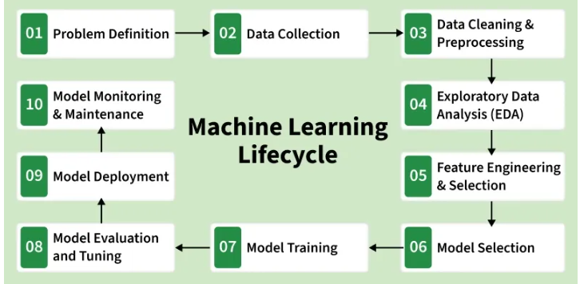
Step 1: Problem Definition
The first step is clearly defining the problem that needs to be solved. A well-framed problem provides the foundation to determine the project goals, expected outcomes and the type of solution required.
- Ensures alignment between business needs and technical solutions
- Define project objectives, scope and success criteria
- Ensure clarity in desired outcomes

Step 2: Data Collection

Data Collection phase involves systematic collection of datasets that can be used as raw data to train model. The quality and variety of data directly affect the model’s performance.

Here are some basic features of Data Collection:
- Relevance: Collect data should be relevant to the defined problem and include necessary features.
- Quality: Ensure data quality by considering factors like accuracy and ethical use.
- Quantity: Gather sufficient data volume to train a robust model.
- Diversity: Include diverse datasets to capture a broad range of scenarios and patterns.

Step 3: Data Cleaning and Preprocessing

Raw data is often messy and unstructured and if we use this data directly to train then it can lead to poor accuracy. We need to do data cleaning and preprocessing which often involves:
- Data Cleaning: Address issues such as missing values, outliers and inconsistencies in the data.
- Data Preprocessing: Standardize formats, scale values and encode categorical variables for consistency.
- Data Quality: Ensure that the data is well-organized and prepared for meaningful analysis.

Step 4: Exploratory Data Analysis (EDA)

To find patterns and characteristics hidden in the data Exploratory Data Analysis is used to uncover insights and understand the dataset's structure. During EDA patterns, trends and insights are provided which may not be visible by naked eyes. This valuable insight can be used to make informed decision.

Here are the basic features of Exploratory Data Analysis:
- Exploration: Use statistical and visual tools to explore patterns in data.
- Patterns and Trends: Identify underlying patterns, trends and potential challenges within the dataset.
- Insights: Gain valuable insights for informed decisions making in later stages.
- Decision Making: Use EDA for feature engineering and model selection.

Step 5: Feature Engineering and Selection
Feature Engineering Selection is a transformative process that involve selecting only relevant features to enhance model efficiency and prediction while reducing complexity.
Here are the basic features of Feature Engineering and Selection:
- Feature Engineering: Create new features or transform existing ones to capture better patterns and relationships.
- Feature Selection: Identify subset of features that most significantly impact the model's performance.
- Domain Expertise: Use domain knowledge to engineer features that contribute meaningfully for prediction.
- Optimization: Balance set of features for accuracy while minimizing computational complexity.

Step 6: Model Selection

For a good machine learning model, model selection is a very important part as we need to find model that aligns with our defined problem, nature of the data, complexity of problem and the desired outcomes.

Here are the basic features of Model Selection:
- Complexity: Consider the complexity of the problem and the nature of the data when choosing a model.
- Decision Factors: Evaluate factors like performance, interpretability and scalability when selecting a model.
- Experimentation: Experiment with different models to find the best fit for the problem.

Step 7: Model Training
With the selected model the machine learning lifecycle moves to model training process. This process involves exposing model to historical data allowing it to learn patterns, relationships and dependencies within the dataset.
Here are the basic features of Model Training:
- Iterative Process: Train the model iteratively, adjusting parameters to minimize errors and enhance accuracy.
- Optimization: Fine-tune model to optimize its predictive capabilities.
- Validation: Rigorously train model to ensure accuracy to new unseen data.
Step 8: Model Evaluation and Tuning
Model Evaluation involves rigorous testing against validation or test datasets to test accuracy of model on new unseen data. It provides insights into model's strengths and weaknesses. If the model fails to acheive desired performance levels we may need to tune model again and adjust its hyperparameters to enhance predictive accuracy.
Here are the basic features of Model Evaluation and Tuning:
- Evaluation Metrics: Use metrics like accuracy, precision, recall and F1 score to evaluate model performance.
- Strengths and Weaknesses: Identify the strengths and weaknesses of the model through rigorous testing.
- Iterative Improvement: Initiate model tuning to adjust hyperparameters and enhance predictive accuracy.
- Model Robustness: Iterative tuning to achieve desired levels of model robustness and reliability.
Step 9: Model Deployment
Now model is ready for deployment for real-world application. It involves integrating the predictive model with existing systems allowing business to use this for informed decision-making.
Here are the basic features of Model Deployment:
- Integrate with existing systems
- Enable decision-making using predictions
- Ensure deployment scalability and security
- Provide APIs or pipelines for production use
Step 10: Model Monitoring and Maintenance
After Deployment models must be monitored to ensure they perform well over time. Regular tracking helps detect data drift, accuracy drops or changing patterns and retraining may be needed to keep the model reliable in real-world use.
Here are the basic features of Model Monitoring and Maintenance:
- Track model performance over time
- Detect data drift or concept drift
- Update and retrain the model when accuracy drops
- Maintain logs and alerts for real-time issues

Bias-Variance Trade Off
Bias and Variance are two key concepts that explain the errors a machine learning model can make during prediction. A good model should not only perform well on training data but also generalize well to unseen data. Understanding these concepts helps determine whether a model is too simple or too complex.
- Bias: Error caused by overly simple assumptions in the model, which may lead to underfitting.
- Variance: Error caused by the model being too sensitive to training data, which may lead to overfitting.
- Goal: Balance bias and variance so the model captures patterns while still generalizing well to new data.

Bias Variance Tradeoff
The bias variance tradeoff describes the balance between a model being too simple and too complex. A simple model may miss important patterns (high bias), while a very complex model may learn noise from training data (high variance). The aim is to balance both so the model performs well on new data.
The total prediction error can be expressed as:
$$TotalError=Bias^{2}+Variance+IrreducibleError$$
Here:
- Bias²: Error caused by incorrect assumptions in the model.
- Variance: Error caused by sensitivity to training data.
- Irreducible Error: Random noise in the data that cannot be eliminated.
Importance of Bias Variance Tradeoff
Understanding the bias variance tradeoff helps in building better machine learning models.
- Helps models perform well on unseen data.
- Helps choose appropriate algorithms and complexity.
- Helps achieve better model performance.
Cross Validation
Cross validation is used to evaluate how well a model performs on different subsets of the dataset. It divides the dataset into multiple parts and trains the model on different combinations of these parts to ensure the model generalizes well. Some important aspects of cross validation include:
- Dataset is divided into multiple parts (folds).
- Model is trained and tested on different combinations of these folds.
- Helps select a model that performs consistently across different data subsets.
- Reduces the risk of the model performing well only on training data.
Regularization
Regularization controls model complexity by adding a penalty to the loss function. This prevents the model from fitting noise in the training data and helps improve generalization.
- Controls complexity by penalizING overly large model parameters
- Common methods include L1 (Lasso) and L2 (Ridge) regularization.
Feature Selection
Feature Selection involves choosing the most relevant features for training the model. Removing unnecessary features simplifies the model and reduces variance.
- Removes irrelevant features.
- Improves performance by reducing overfitting and improves prediction accuracy.
Ensemble Methods
Ensemble Methods combine predictions from multiple models to produce more stable and accurate results.
- Combines multiple models together to improve predictions.
- Examples are Bagging, Random Forest and Boosting.

Exploratory Data Analysis

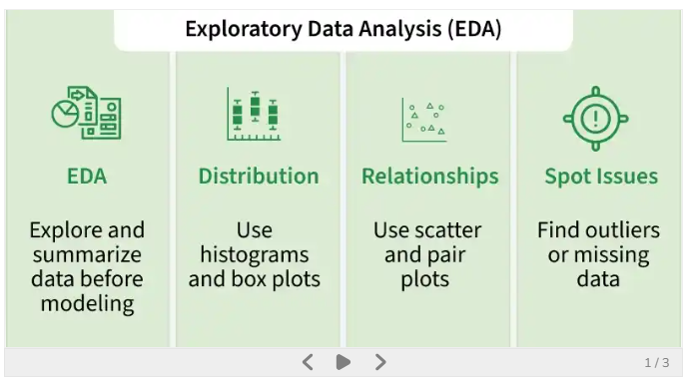

Steps

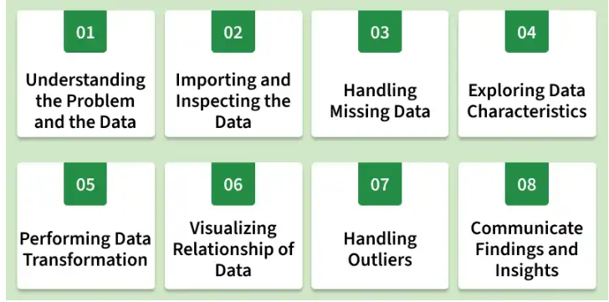

Step 1: Understanding the Problem and the Data

The first step in any data analysis project is to fully understand the problem we're solving and the data we have. This includes asking questions like:
- What is the goal or problem we are trying to solve?
- What variables are present in the dataset and what do they represent?
- What types of data are available (numerical, categorical, text etc.)?
- Are there any data quality issues or limitations?

Step 2: Importing and Inspecting the Data

The next step is to load the dataset into tools like Python or R and inspect it. These checks give a basic understanding of the dataset.
- Load the dataset properly.
- Check the number of rows and columns.
- Identify missing values.
- Verify the data type of each variable.
- Look for errors, invalid values or unusual data points.

Step 3: Handling Missing Data

Missing data is common in many datasets and can affect the quality of analysis. During EDA, it is important to identify and handle missing values properly to avoid incorrect results.
- Understand why data is missing, as this helps in selecting the right approach.
- Decide whether to remove or fill missing values, since removal can cause bias while imputation preserves data.
- Use suitable imputation methods such as mean, median, regression or machine learning techniques like KNN or decision trees.
- Consider the impact of missing data, as it can still introduce uncertainty even after imputation.

Step 4: Exploring Data Characteristics

After handling missing data, the next step is to examine the main characteristics of the dataset. This helps us understand how the data is distributed, detect unusual values and identify potential issues before further analysis.
- Check data distribution to understand how values are spread across the dataset.
- Measure central tendency using mean, median and mode to find the typical value of the data.
- Measure variability using standard deviation to see how much the values vary.
- Analyze distribution shape using skewness and kurtosis.
- Identify outliers or anomalies that may affect the analysis.

Step 5: Performing Data Transformation

Data transformation prepares the dataset for better analysis and modelling. Depending on the dataset, we may need to modify or convert the data so that it is in a suitable format for analysis.
- Scaling or normalizing numerical variables like min-max scaling or standardization.
- Encoding categorical variables for machine learning like one-hot encoding or label encoding.
- Applying mathematical transformations like logarithmic square root to correct skewness or non linearity.
- Creating new features by deriving useful information from existing variables
- Aggregating or grouping data based on specific variables or conditions.

Step 6: Visualizing Relationship of Data

Data visualization helps us understand patterns, trend and relationships in the dataset that may not be clear from numbers alone.
- Bar charts and pie charts help analyze categorical data distribution.
- Histograms, box plots and density plots show distribution and detect outliers in numerical data.
- Scatter plots and correlation measures help analyze relationships between variables.

Step 7: Handling Outliers

Outliers are data points that differ significantly from other observations. They may arise due to errors or genuine variations in the data.
- Using statistical methods such as Interquartile Range (IQR) or Z-score to identify extreme values.
- Analyze outliers carefully before taking any action.
- Use domain knowledge to determine whether they are valid or erroneous.
- Apply techniques like capping or transformation if necessary.
- Remove outliers only when they are clearly incorrect or harmful to analysis.

Step 8: Communicate Findings and Insights

The final step in EDA is to clearly present the results of the analysis. This helps others understand the insights discovered and the conclusions drawn from the data.
- State the goal and scope of the analysis.
- Provide background or context so the approach is easy to understand.
- Use visualizations to support findings and make results clearer.
- Highlight key insights, patterns, or anomalies discovered in the data.
- Mention limitations or challenges faced during the analysis.
- Suggest next steps or areas that require further investigation.

